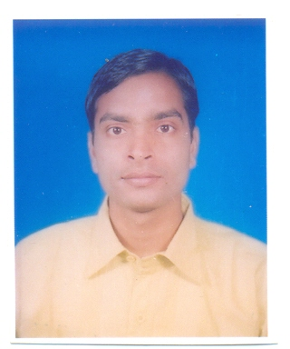

***Curriculum Vitae***

***Raju Kumar***

**CAREER OBJECTIVE**

To work with an organization where my knowledge, experience and my skills can utilize at the maximum level and the Time I can get opportunities to the with the growth of organization

**Experience**

* Working as Executive Assistant in the Office of Dy. Register, Estate Department in Sharda University June 2013 to till date.
* Worked as Personal Assistant in office of the Dean & Advisor to Chancellor, School of Engineering & Technology in Sharda University March-2012 to June 2013.
* Worked as Personal Assistant in the Office of Registrar (Establishment) from 2008 to March 2012 in Sharda University.
* Worked as Computer Operator in the Institute of Computer Accountant from January 2008 to October 2008.

**Qualification**

* Pursuing Post Graduation from Nalanda Open University
* Graduation passed from Veer Kunwar Singh University,
* Intermediate passed from Bihar Intermediate Education Council
* High School passed from Bihar School Examination Board

**Technical Qualification**

* B.ed
* Diploma in Computer Accounting from “The Institute of Computer Accountant”.

**Computer Skills**

* DOS , MS-Word, Excel, Power Point , Carol Draw
* Internet

**Job Profile**

* Maintenance of official documents (File Management).
* Taking dictation from higher authorities.
* Preparation of notices and memos, postage.
* Receiving mails from different departments and through DAK and send them at proper place.
* Communication through internet, correspondence / dispatch letters of students to their parents as well as students.
* Helping in organizing different visit (e.g. UPTU, AICTE, etc.) & meeting (e.g. Governing Body & internal meetings).
* Maintenance of employee record, maintenance of employees leave records.
* Making PowerPoint presentations.
* Making consolidated time tables for Dy. Registrar, etc.
* Assist to Inter Hostel Administration to Hostel allotment of Students

**Strength**

* Positive attitude..
* Mobility, Ready to do any nature of job.

**Key Responsibilities & Initiatives**

* Also Working as help of Warden in Hostel arrangement for Boys Hostel
* Maintain Boys record in SIM Software in Computer

**Knowledge & Expertise**

* Typing knowledge of Englishand Hindi
* Adequate knowledge of Internet
* Correspondence in Hindi and English
* Office Management

**Personal information**

Date of Birth : 26th January 1985

Father’s Name : Madhav Kant

Mailing Address : G-11, Gamma –II, Greater Noida (U.P)

Sex : Male

Nationality : Indian

Marital Status : Married

Language known : English & Hindi

Hobby : Listening Music & Playing Cricket

E-mail Address : [rajmauar47@gmail.com](mailto:rajmauar47@gmail.com) , mauarjee47@yahoo.in

Contact No. : 8802708611

**Date:-**

**Place:-**

**Raju Kumar**